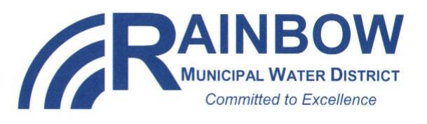 COMMUNICATIONS Committee Meeting

RAINBOW MUNICIPAL WATER DISTRICT
Monday, January 9, 2017
Communications Committee Meeting - Time: 3:30 p.m.

District Office 3707 Old Highway 395 Fallbrook, CA 92028

Notice is hereby given that the Communications Committee will be holding a regular meeting beginning at 3:30 p.m. on Monday, January 9, 2017.

AGENDA

CALL TO ORDER

2. PLEDGE OF ALLEGIANCE

ROLL CALL: Mike Daily (Chair) _____ Jeanna Kirby (Vice Chair) _____

Members: Helene Brazier _______ Elysian Kurnik _______

Hayden Hamilton _______

Alternates: Cynthia Gray_____

- SEATING OF ALTERNATES

5. ADDITIONS/DELETIONS/AMENDMENTS TO THE AGENDA (Government Code §54954.2)

6. PUBLIC COMMENT RELATING TO ITEMS NOT ON THE AGENDA

COMMITTEE ACTION ITEMS

*7. APPROVAL OF MINUTES
A. December 5, 2016

8. DISCUSSION REGARDING COMMITTEE MEMBERSHIP

9. WELCOME PACKET UPDATE

10. COMMUNICATIONS PLAN/TOPICS

11. REVIEW AND ANALYSIS OF RMWD RELATED MEDIA STORIES

12. COMMITTEE MEMBER COMMENTS

13. LIST OF SUGGESTED AGENDA ITEMS FOR THE NEXT SCHEDULED COMMUNICATIONS COMMITTEE MEETING
14. ADJOURNMENT

ATTEST TO POSTING:

Helene Brazier  Secretary of the Board |  | Date and Time of Posting  Outside Display Cases

