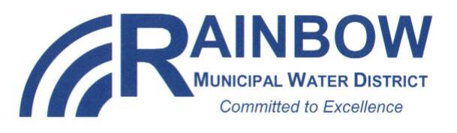 ENGINEERING SERVICES Committee Meeting

RAINBOW MUNICIPAL WATER DISTRICT
Wednesday, January 4, 2017
Engineering Services Committee Meeting - Time: 3:00 p.m.

District Office 3707 Old Highway 395 Fallbrook, CA 92028

Notice is hereby given that the Engineering Services Committee will be holding a regular meeting beginning at 3:00 p.m. on Wednesday, January 4, 2017.

AGENDA

CALL TO ORDER

- PLEDGE OF ALLEGIANCE

ROLL CALL: Timothy Prince (Chair)_____ Harry Stitle _____ (Vice Chair)

Members: Tom Taufer ____ Jim Murray ________

Helene Brazier _____ Lee Kirby _____
Mick Ratican ____

Alternates: John Robertson Jr. ____ Robert Marnett ____

- SEATING OF ALTERNATES

5. ADDITIONS/DELETIONS/AMENDMENTS TO THE AGENDA (Government Code §54954.2)

6. PUBLIC COMMENT RELATING TO ITEMS NOT ON THE AGENDA

COMMITTEE ACTION ITEMS

*7. APPROVAL OF MINUTES
A. December 7, 2016

8. DISCUSSION AND POSSIBLE ACTION TO APPOINT 2017 COMMITTEE OFFICERS

9. CAPACITY FEE UPDATE

10. AUTOMATIC METERING INFRASTRUCTURE (AMI) UPDATE

11. SLR IMPORTED WATER RETURN FLOW UPDATE

12. LIST OF SUGGESTED AGENDA ITEMS FOR THE NEXT SCHEDULED ENGINEERING SERVICES COMMITTEE MEETING

13. ADJOURNMENT

ATTEST TO POSTING:

Helene Brazier  Secretary of the Board |  | Date and Time of Posting  Outside Display Cases

